General report GYC-FGM West and central Africa 2023

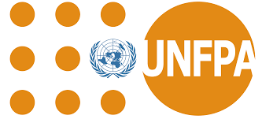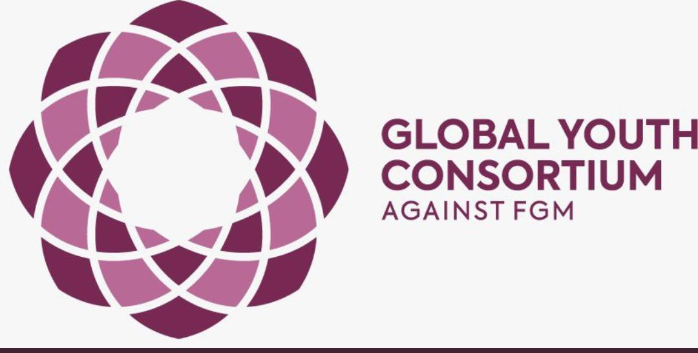

Report by Maman Daouda Boukary
West and central Africa Secretary

Introduction
The collective efforts of the Global Youth Consortium (GYC) in West and Central Africa particularly in Senegal and Ivory Coast, along with projects in Cameroon, Niger, and Sierra Leone, exemplify a shared commitment to eradicating female genital mutilation (FGM) and promoting gender-based violence (GBV) awareness. The GYC-SENEGAL 2023 Annual Report highlights Senegal's strides in actively participating in regional and global events, forming partnerships, and endorsing crucial declarations. Ivory Coast's focus on showcasing the potential of its youth underscores the importance of targeted initiatives, while Cameroon's "Awakening Against FGM In Mbonjo" project navigates challenges to engage communities effectively.

Senegal
The GYC-SENEGAL 2023 Annual Report outlines the collective efforts of the SENEGAL FGM-YCONSORTIUM, established in March 2022, comprising diverse youth from civil society organizations united in the common goal of eradicating gender-based violence, especially female genital mutilation (FGM).
To achieve their objectives and structure the SENEGAL consortium effectively, the focal point initiated the establishment of key positions in 2022 under the regional president's agreement, including Administrative and Financial Manager, Program Coordinator, and Communication and Advocacy Manager. The team allocated these roles based on submitted manifestos.
Throughout the year, SENEGAL actively participated in various regional and global events, both online and in-person. Notable engagements included serving as panellists in an online event organized by "Justice and Dignity for the Women of Sahel" during the 67th session of the CSW in March. Another significant event was a regional retreat organized by the Global Media Campaign to End FGM/C (GMC) in Saly, Senegal, with plans to secure funding for anti-FGM media campaigns.
The consortium members also participated as panellists in the virtual conference for young Francophone Africans on FGM, organized by the Francophone section of the consortium. In July 2022, SENEGAL, represented by its focal point, participated in the Women Deliver international conference in Rwanda, actively engaging in the Pre-Conference on FGM and endorsing the Kigali Declaration on Female Genital Mutilation.
Efforts to establish potential partnerships were evident through contact with Mr Pedro from UNFPA. Additionally, the consortium actively participated in virtual "Youth Workshops" organized by Orchid Project, focusing on FGM/C.
Ivory coast
Summary of Activities:
Introduction:
In 2023, the focus was on showcasing the potential of young Ivorians in eliminating Female Genital Mutilation/Cutting (MGF/e). The annual work plan included online meetings, exchanges with youth nationwide, and training sessions to equip volunteers for awareness, information, training, and advocacy actions. The report highlights activities in key thematic areas: Mutilations Génitales Féminines, Gender-Based Violence, and Sexual and Reproductive Health.

International Online Conference on MGF/e:
On June 18, 2023, a significant online conference was held in collaboration with GYC sections from West Africa. The theme centered around promoting MGF abandonment in West Africa and assessing youth involvement. Notable speakers included representatives from Senegal, Niger, Guinea, Burkina Faso, and Côte d'Ivoire.
- Senegal's Involvement: Emphasized the commitment of the Senegalese government in combating MGF/e through constitutional measures and collaboration with various organizations.
- Niger's Progress: Reported a decreasing trend in MGF/e in Niger, attributing success to a national committee and government commitment through ministries.
- Guinea's Challenge: Highlighted Guinea's high prevalence of excision and government efforts, with particular emphasis on youth involvement through awareness programs.
- Burkina Faso's Struggle: Noted government support and UNFPA assistance but faced challenges due to political instability and the dissolution of a crucial cell dedicated to combating MGF/e.
- Ivory Coast's Legal Framework: Discussed Ivory Coast's legal framework against MGF/e, supported by entities like the Directorate for Gender Promotion and Equity.
- National Strategy: Outlined a national plan to reduce MGF prevalence by 10 points before 2025, focusing on prevention, legal measures, survivor support, improved coordination, and data collection.
- Youth Participation Challenge: Highlighted a significant challenge in the insufficient consideration of Ivorian youth in the national strategy, stressing the need for dedicated spaces, training, and support for youth initiatives.
- Local Initiative: Described a specific activity in Danané, training men and boys to strengthen collaboration and take targeted actions towards MGF/e abandonment.
1. Online Capacity Building Workshop for GYC Côte d'Ivoire Volunteers on Gender-Based Violence (GBV):
- Objective: Strengthen the partnership with young individuals to transform social and gender norms, focusing on combating Female Genital Mutilation (FGM) in specific regions.
- Participants: 20 selected volunteers (10 females, 10 males) out of 30 preselected through an online form.
- Dates: July 27-30, 2023, conducted on Google Meet.
- Training Team: Expert humanitarian, former Commissioner, GBV specialist, and reproductive health specialist.
- Modules: Covered GBV basics, FGM, Sexual and Reproductive Health, and Community Mobilization Techniques.
- Debated Topics: Management of FGM cases, causes of GBV, youth involvement, contraception methods, promotion of sexual and reproductive health rights, effective community mobilization, application of laws related to FGM, and identification and handling of GBV/FGM cases.
2. Series of Online Conferences by GYC Côte d'Ivoire:
- Objective: Promote the Global Youth Consortium Against FGM and highlight national initiatives against Female Genital Mutilation.
- Dates:September 3, 13, and 16, 2023, on Google Meet.
- Themes:
- Theme 1: Introduction to the Global Youth Consortium Against FGM, presented by Mr. Bamba Djakaridja.
- Theme 2: GBV, FGM, early/forced marriage, presented by Mr. Koffi Socrate, a senior expert in VBG.
- Theme 3: The role of youth in the fight against FGM in Côte d'Ivoire, presented by Mr. Bamba Djakaridja, Miss Tanou Safiatou, and Mr. Koné Moussa, members of GYC Côte d'Ivoire.
- Key Points Discussed: Origin, vision, mission, objectives, and values of GYC; distinctions between gender and sex; various types of GBV; and the crucial role of youth in combating FGM.
- Attendees: 48 participants from women's organizations, youth groups, and public administration.
3. Training Workshop on Female Genital Mutilation (FGM) for Men and Young Boys:
- Objective:Strengthen partnerships with both men and women to transform social and gender norms, particularly focusing on ending FGM in specific regions.
- Location and Dates: Man, November 23-25, 2023.
- Participants: Originally planned for 20, trained 26 individuals (2 females, 24 males).
- Modules: Covered gender concepts, FGM, Advocacy, and national laws on FGM.
- Outcome: Developed an action plan for the Tonkpi region.
- Training Team: Experienced individuals in gender-based violence, legal aspects, and community leadership.
4. Commemoration of 16 Days of Activism Against Gender-Based Violence (GBV):
- Objective: Raise awareness, provide information, and conduct training as part of the GYC Côte d'Ivoire program against FGM.
- Locations:Abidjan, Man, Bouaké, Yamoussoukro, and Soubré.
- Key Events
- Launch in Abidjan: Training at Lycée Municipal 1 de Koumassi, sensitizing 54 individuals.
- Sensitization in Man: Workshop on GBV and FGM for 37 adolescents.
- Community Dialogue in Bouaké: Discussion in Tchelekro village involving 29 women.
- Mass Sensitization in Yamoussoukro: Engaged with 250 individuals at the grand market.
- Mass Sensitization in Soubré: Reached 440 people at the grand market.
- School Sensitization in Soubré: Addressed 111 students on GBV and challenges during schooling.
- Final Activity in Bouaké: Combatting FGM and promoting sexual and reproductive health for 122 students.
Others pictures links
Abidjan
https://drive.google.com/drive/folders/1cakbk9otX3NB9HGJB7axX4K9sPOTQmSp?usp=drive_link
Bouaké
https://drive.google.com/drive/folders/1-AmBStVVW0a8AvirPseeLSaKqTHZ3-UR?usp=drive_link
Man
https://drive.google.com/drive/folders/1S_px_xhI0sI9EpuwlsrlYPig1A_TX8Wn?usp=drive_link
Soubré
https://drive.google.com/drive/folders/1-BabGykP7uVm123tpzZJSNQ9OEnOAu0r?usp=drive_link
Yamoussoukro
https://drive.google.com/drive/folders/1-2ZWnslwsj2EE3qd761U1KEcEP8JrtbI?usp=drive_link
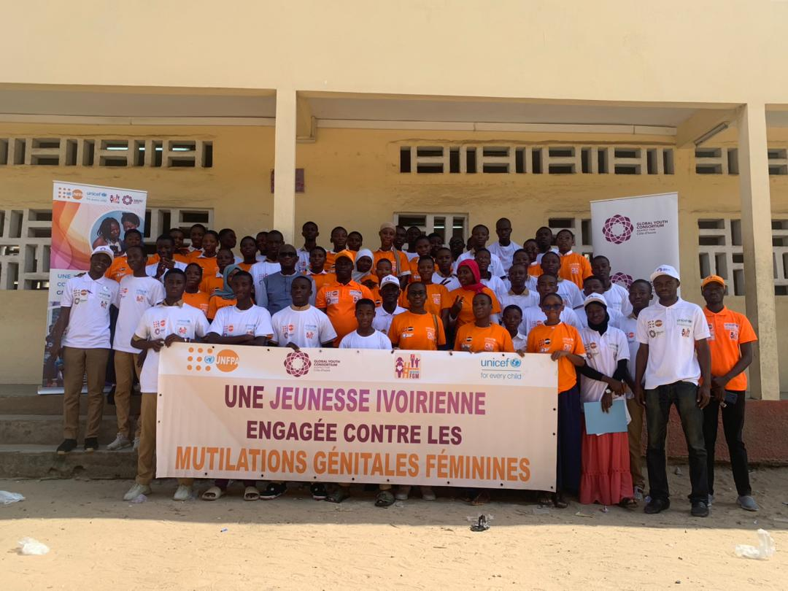

Cameroon
Project Summary: "Awakening Against FGM In Mbonjo"
The project aimed to combat female genital mutilation (FGM) in Mbondjo, Cameroon, addressing the challenges of limited data access and prevalence disparities across regions.
Objectives:
- Primary Goal: Raise awareness and inform Mbondjo communities about the harms of FGM and ways to combat it.
- Specific Objectives: Inform about FGM risks, promote medical and psychological care, raise awareness on women's and girls' rights, and engage the community to end FGM.
Planned Activities:
1. Organization of focus groups.
2. Mass sensitization at SOCAPALM Camp Stadium during football matches.
3. Door-to-door awareness campaign.
4. Film screening on girls' rights.
5. Two-day mobile clinic on FGM.
6. Formation of a multi-actor protection committee.
Expected Results:
- Conducted six focus groups with varied participants.
- Reached over 150 people through mass sensitization.
- Informed 118 households through door-to-door campaign.
- Engaged 70 individuals through the mobile clinic.
- Successfully screened the film and initiated a 2-hour discussion.
Project Achievements:
- Established a Protection Committee with 40 trained members.
- Enhanced community knowledge on FGM.
- Raised awareness among host and migrant communities.
- 31 individuals joined the Protection Committee.
- Engaged traditional and religious leaders against FGM.
- Received community requests for guidance on FGM-related situations.
New Alliances and Project Sustainability:
- Formed a multi-actor coordination framework supervised by the sub-prefecture.
- Utilizes human, traditional, material, and administrative-juridical resources.
- Key activities include sensitizing, maintaining vigilance, and reporting on FGM practices.
Challenges Encountered:
1. Weather-related issues during the rainy season.
2. Regular power outages.
3. Difficulty implementing morning activities due to agricultural demands.
4. Poor road conditions.
5. Cultural barriers, particularly with communities from the Extreme North.
Conclusion:
The project successfully engaged the Mbondjo community, fostering awareness and alliances to combat FGM. Challenges were overcome, and new structures aim to sustain the initiative. Ongoing efforts include sensitization, vigilance, and reporting within a multi-stakeholder framework.

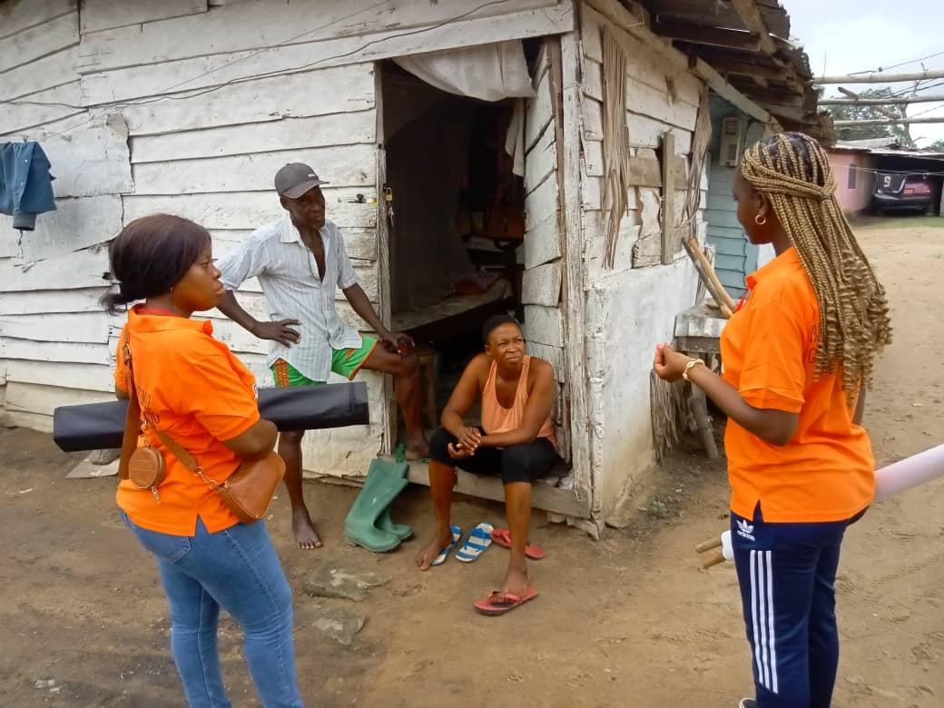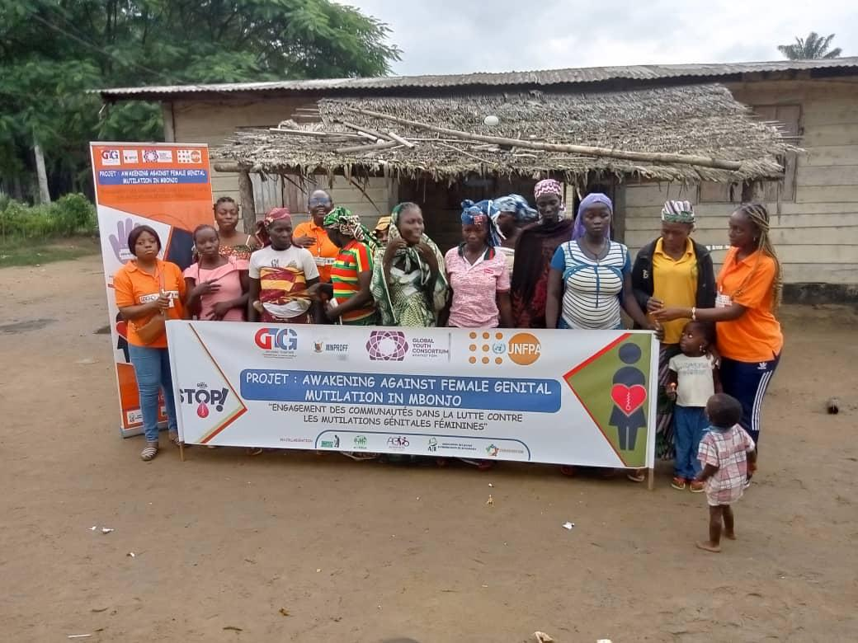

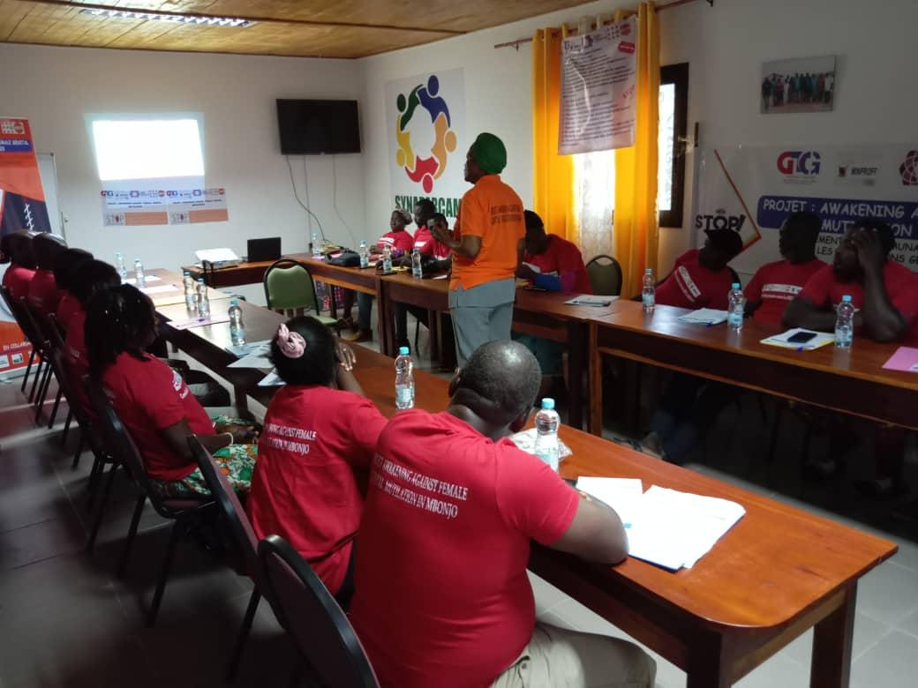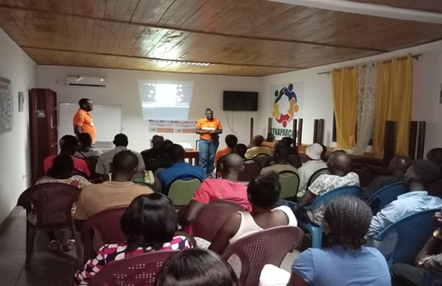

Niger
Participated in the Women Deliver 2023 conference in Kigali, Rwanda, starting on July 15, 2023. The pre-conference, co-organized by various entities, focused on ending female genital mutilation (FGM/C) and fostered global collaboration. Engaged in the panel on Harnessing the Power of Young People to End FGM/C, highlighting gaps, solutions, and advocating for effective communication, smart approaches with funders, and intergenerational knowledge transfer.
Attended the Women Deliver conference opening at BK Arena on July 17, 2023, inaugurated by President Paul Kagamé. Joined workshops and panels on July 18, focusing on Research Approaches to Sexual and Reproductive Health Rights. Also participated in an inclusive training for quality education, followed by networking opportunities. Engaged in the panel "Girls at the Center" on July 19, emphasizing community partnerships to end FGM/C, featuring diverse panelists.
On the final day, July 20, 2023, participated in panels, workshops, and the closing ceremony of the Women Deliver conference. The experience involved artistic activities in the youth area, contributing to the global dialogue on women's rights and reproductive health.
Additionally, GYC FGM Niger organized an online conference in collaboration with GYC FGM from French-speaking African countries. The conference shed light on FGM practices, sharing insights, best practices, and actions needed to end the practice by 2030. During the 16 Days of Activism, an online campaign was conducted on social networks. The focal point actively engaged at various levels in advocacy actions internationally and within Africa.
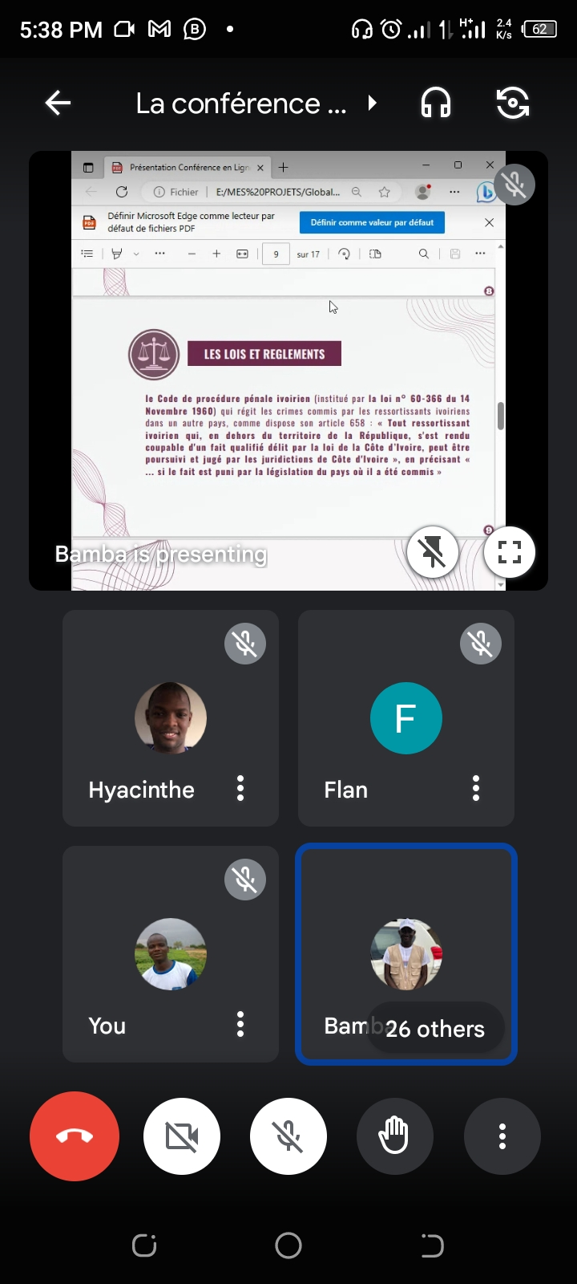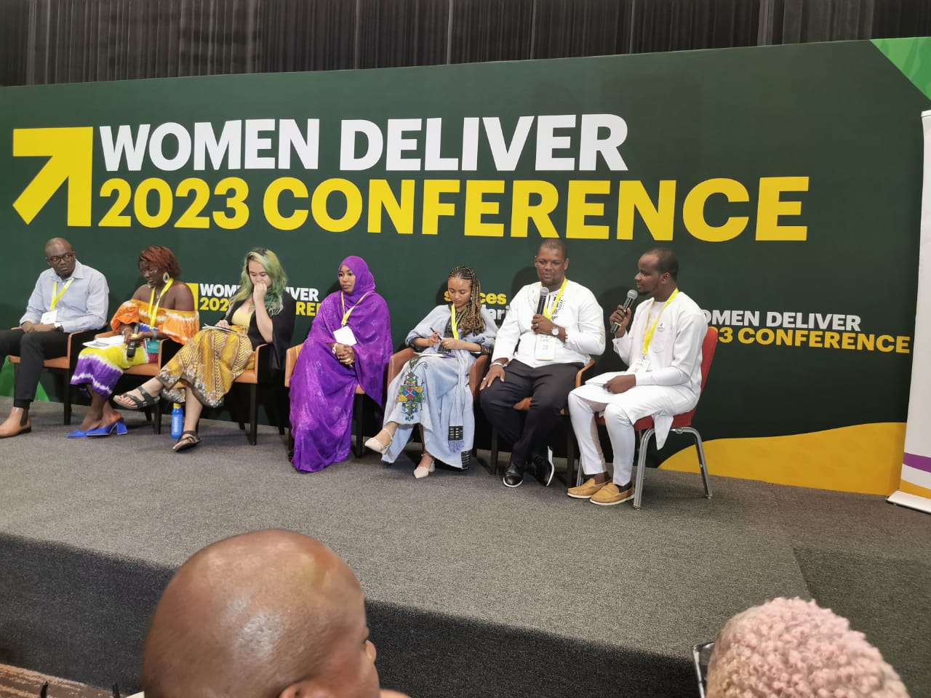
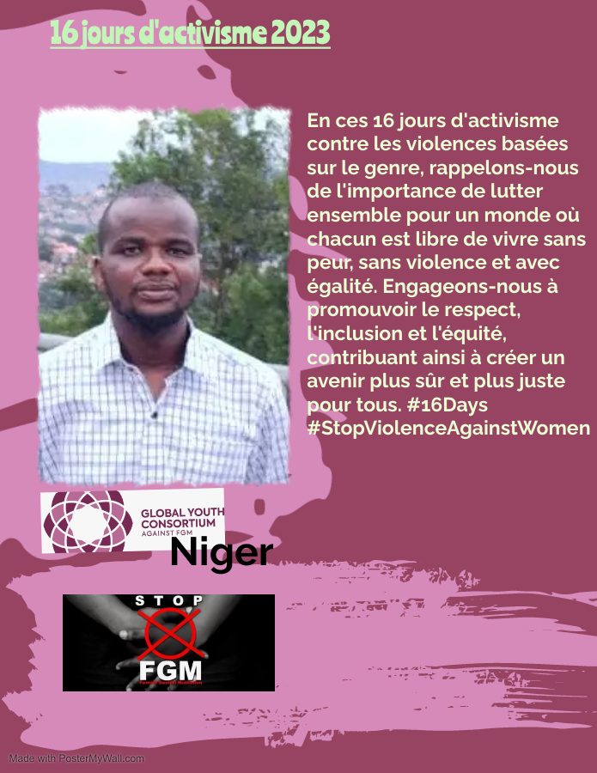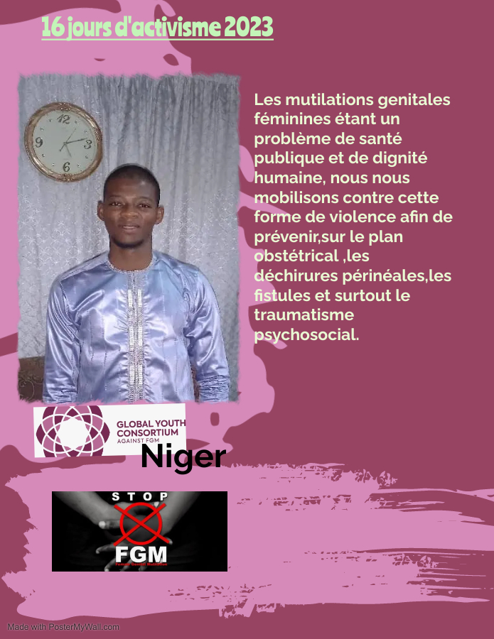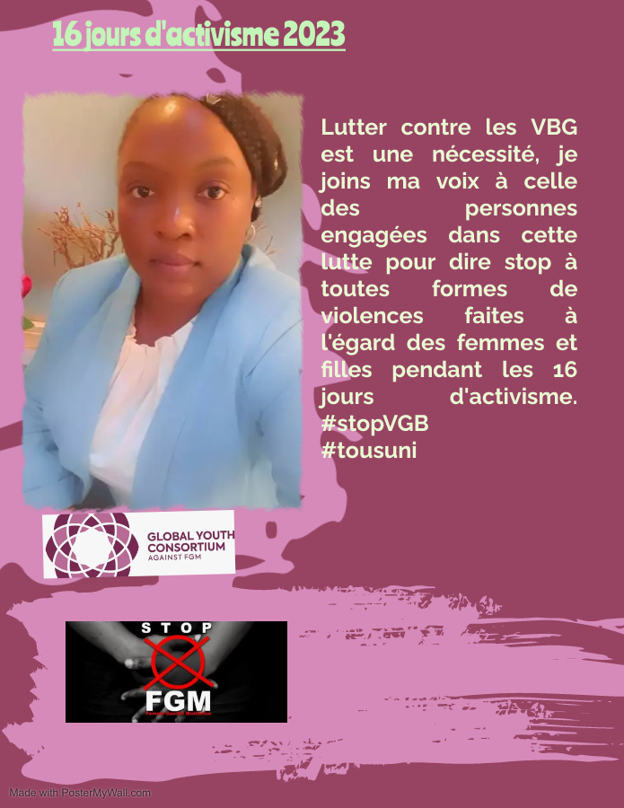

Sierra Leone
Resume Report: Combating Female Genital Mutilation (FGM) in Sierra Leone - Implementation and Challenges

Implementation Overview:
The project, initiated in response to Sierra Leone's alarming FGM rates, aims to combat this practice through the Global Youth Consortium against Female Genital Mutilation (GYC FGM) in collaboration with the Spotlight Initiative Regional Programme and UNFPA Sierra Leone. The project targets Kono District, known for high violence against women and girls, particularly associated with mining activities.

Methodology:
The initiative utilized various strategies, including community and school sensitizations, intergenerational dialogues, and multimedia engagement like radio and TV talk shows. A key event on the International Day of zero tolerance against FGM involved street theatre and an intergenerational dialogue session with key stakeholders in Koidu City, Kono District.

Key Achievements:
1. Stakeholder Commitment: Key stakeholders, including community leaders, law enforcement officials, and school authorities, exhibited understanding of FGM dangers, committing to actively oppose the practice.
2. Youth Empowerment: Girls in targeted schools pledged to be role models in the fight against FGM, and school authorities expressed a willingness to integrate discussions on FGM into the curriculum.
3. Community Outreach Impact: Community sensitizations and street mob activities positively influenced parents and caregivers, especially male counterparts, towards supporting the end of FGM.
Lessons Learned:
1. Involving Men: Including men in discussions about the development and well-being of women and girls proved effective due to their influential roles in decision-making within households.
2. Knowledge of Existing Laws: Some stakeholders were aware of existing laws against harmful practices but cited lack of enforcement, emphasizing the need for stronger implementation.
3. Messaging Improvement: Developing catchy and age-appropriate FGM messages is crucial for effective awareness campaigns.

Challenges:
1. Identification Challenges: Lack of identification documents for GYC FGM members hindered effective implementation.
2. Logistical Support: Limited mobility, logistical support, and incentives slowed down activities.
3. Resistance to Change: Traditional norms and slow societal change posed challenges during sensitization efforts.
4. Lack of Platforms: Insufficient platforms for stakeholders, especially young girls, hindered their ability to amplify their voices as role models in ending FGM.
5. Political Exploitation: The absence of a national law on zero tolerance allowed politicians to exploit FGM for support during elections.

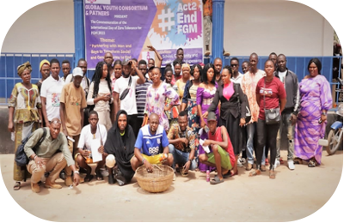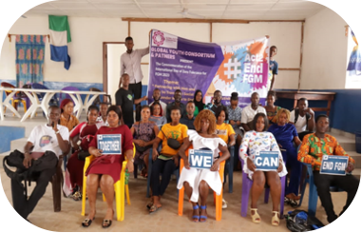

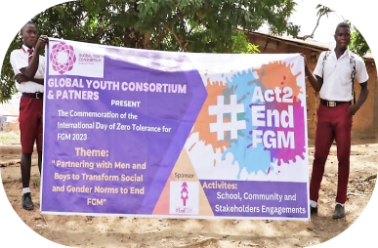

Conclusion
In conclusion, these reports underscore the dedicated efforts across Senegal, Ivory Coast, Cameroon, Niger, and Sierra Leone to combat female genital mutilation (FGM) through the Global Youth Consortium (GYC) and other collaborative initiatives. The commitment of these youth-led organizations is evident in their participation in international conferences, workshops, and targeted activities aimed at raising awareness, fostering partnerships, and advocating for the eradication of FGM.
Senegal's proactive engagement in various events, including the CSW and the Global Media Campaign retreat, showcases a concerted effort to secure funding for anti-FGM media campaigns. Ivory Coast, on the other hand, demonstrates a comprehensive approach through online conferences, capacity-building workshops, and specific initiatives in different regions, albeit facing challenges in youth inclusion.
Cameroon's "Awakening Against FGM In Mbonjo" project tackles FGM challenges with a focus on community engagement, mass sensitization, and the formation of a multi-actor protection committee, showcasing successful outcomes and new alliances.
Niger's involvement in the Women Deliver conference and the organization of online events with French-speaking African countries highlights their dedication to global collaboration and knowledge-sharing. Meanwhile, Sierra Leone's project, supported by GYC FGM and UNFPA, makes strides in stakeholder commitment, youth empowerment, and community outreach, although challenges persist, emphasizing the importance of continual adaptation and improvement in messaging and logistics.
While each country faces unique challenges, the collective pursuit of ending FGM remains resilient. These initiatives contribute to a broader movement, fostering awareness, encouraging collaboration, and empowering communities to combat this harmful practice. The ongoing efforts underscore the necessity of addressing both cultural barriers and legal frameworks while emphasizing the crucial role of youth in achieving lasting change.
These reports depict a panorama of resilience and dedication in the fight against FGM across West Africa. Despite challenges, the projects have fostered community engagement, raised awareness, and established alliances. Whether through online conferences, training workshops, or community outreach, these initiatives collectively contribute to a broader movement aiming for sustainable change. The lessons learned underscore the need for adaptable strategies, inclusive messaging, and continued efforts to overcome obstacles. As these projects move forward, their impact is evident in the commitment of stakeholders, the empowerment of youth, and the growing awareness surrounding FGM and GBV. The journey continues, propelled by a shared vision of a future free from the harms of female genital mutilation.

General Recommendations:

1. Government Commitment: Advocacy for clear government commitment and a national law against FGM is crucial.
2. Improved Logistics: Addressing logistical challenges, providing identification support, and offering incentives can enhance project effectiveness.
3. Community Engagement: Continued community engagement and sensitization efforts to gradually shift societal norms.
4. Policy Approval: Urgent approval and implementation of the National Strategy on the Reduction of FGM is necessary.
5. Youth Empowerment: Creating more platforms for the youth, particularly girls, to amplify their voices in the fight against FGM.
6. Advocate with the UNFPA-UNICEF Joint Program for the fight against female genital mutilation to secure financial support for GYC regionals and countries sections activities.

